1. Introduction
Agriculture is the backbone of many developing countries, including Nepal. Farmers often rely on middlemen to sell their produce, resulting in reduced income and unfair pricing. Customers also face difficulty in getting fresh produce directly from farmers at a reasonable rate. To solve this problem, we propose Farmo, a mobile application that directly connects farmers and customers. The app allows farmers to list their crops and vegetables, and customers can browse available products, compare prices, and place orders directly removing middlemen from the supply chain

2. Aim and Scope

3. Objective
The Main objective of Farmo is as follows:
- To increase the income of farmers by providing platform to sell their crops and goods directly to consumers.

7. Design

7.1 Methodology
Agile Scrum Methodology is an iterative and incremental framework for managing complex software projects. It uses short cycles called Sprints to deliver working features quickly and consistently. It is used because it allows teams to adapt to changing requirements, obtain frequent user feedback, and efficiently mitigate risks by focusing on continuous improvement and collaboration.
.
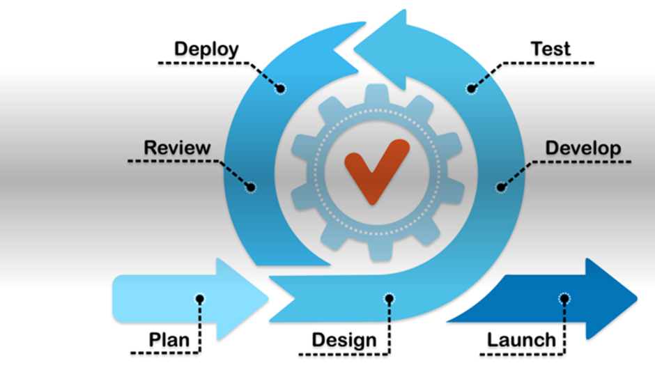
Fig 7.1: Agile Scrum Methodology

7.2 Architectural Diagram
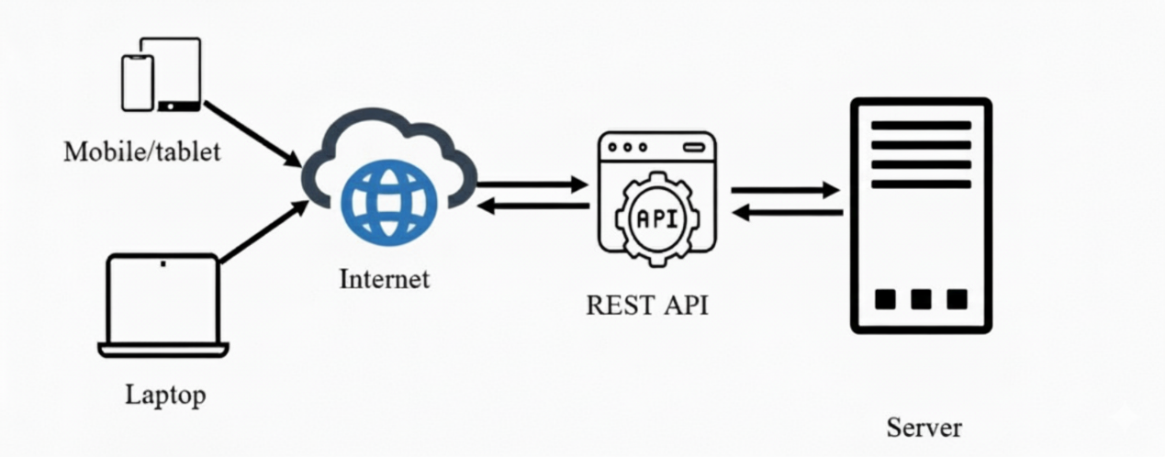

Fig 7.2: Architectural diagram

7.3 ER Diagram
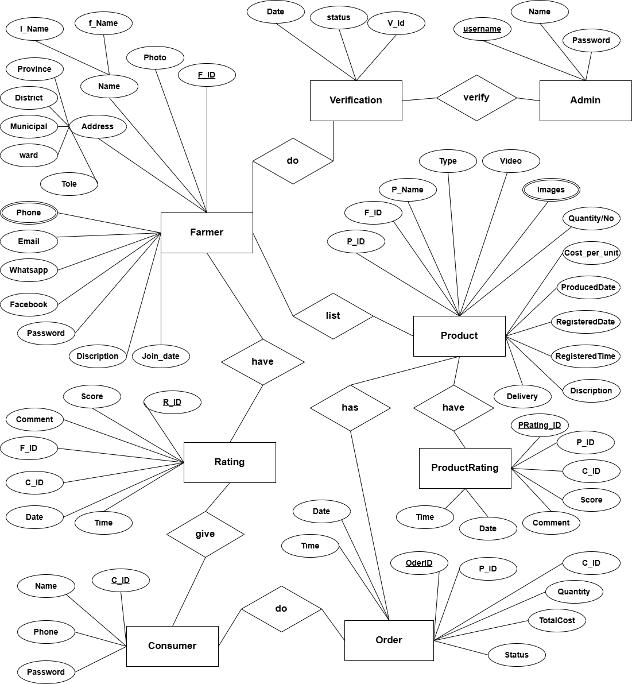
Fig 7.3: ER diagram

7.4 Use Case Diagram

7.4.1 Use case diagram of Admin
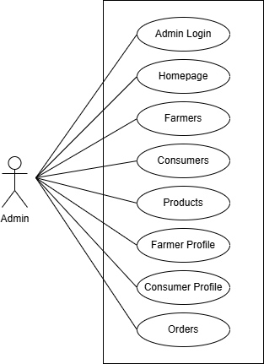
Fig 7.4.1: Use Case diagram for Admin

7.4.2 Use case diagram of User
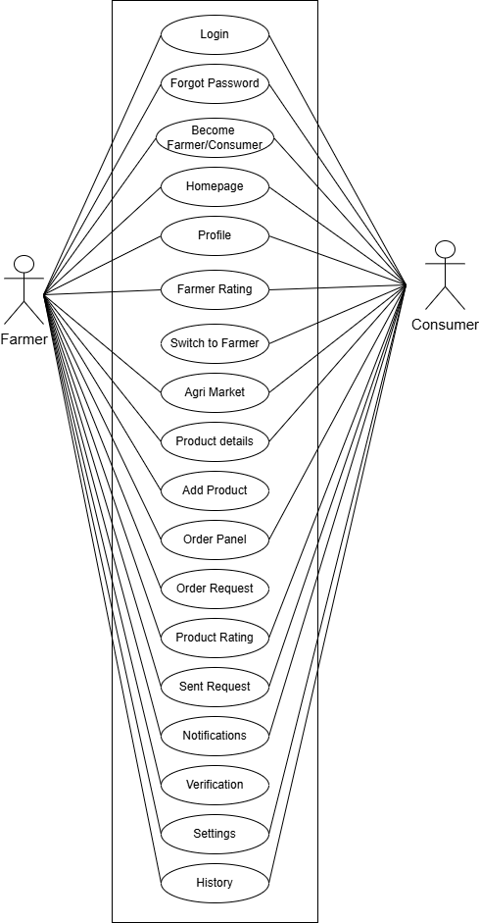
Fig 7.4.2: Use Case diagram for Farmer/Consumer

2.7 Economical feasibility
S.N. | Component | Price
1. | Planning | 1000
2. | Internet surfing | 4000
3. | Documentation | 2000
4. | Miscellaneous | 1500
5. | Total | 8500

Table 2.6: Economical Feasibility

9. Project Time Schedule
The project work is divided into various activities which will be carried out as per given schedule:
Activities | Nov-Dec |  |  |  | Dec-Jan |  |  |  | Jan-Feb
Activities | Week |  |  |  | Week |  |  |  | Week
 | 1 | 2 | 3 | 4 | 5 | 6 | 7 | 8 | 9 | 10
Feasibility Study
Proposal submission
Proposal Defense
System design & Specification
Coding & verification
Integration & Testing
Mid-term Defense
Final testing
Documentation
Final presentation

Fig 7 Project time schedule

10. Conclusion

11. References

